Project Proposal – Cloud IDE

Computing Group Project [ **Group 35** ]



University of Plymouth, UK

NSBM Green University, LK

Define the Problem

When a software is created by several people together rather than by one person, it can be done very quickly. That is because the development process of the relevant software can be shared with each other. This is an easy task in a company. This is because in a typical software development company, all the computers are interconnected so it can be done easily.

But suppose an ordinary team, not a company, does this. There, each other 's computers are not directly connected. Here you have to share the project related to the software created by the team.

Take a look at this example. Imagine that a team is developing a mobile app. Here are the basics: UI Design Process and App Development Process. For the UI design process, you can use online software such as Figma and Lunacy. But think about the app development process. How is it done? The project should be shared with each other.

Software such as Visual Studio provides Team support for this problem.

But can everyone use it? Suppose I am a Linux User, another Mac User, another Windows User.

Simply put, this is our problem.

Solution for the Problem

Our primary objective is to find a solution to this problem. So we think the solution to this is to create a text editor that can be used by anyone or used by any team. After that, we hope to upgrade the Tex Editor to an IDE.

Here we will create a cloud IDE for Web Design.

Target Users

We primarily target web designers.

In addition to web designers, web-based Mobile or Desktop application designers are also targeted.

The bottom line is that we target designers, not developers.

Application features and Description

Here are some of the key features of our Cloud IDE:

* Team Collaboration
* Tam Chat
* Built-In Live Preview
* Built-In Storage per Team

In addition, there are some basic features that a web design IDE should have:

* UI and Editor Color Schemes
* File and Folder Management
* Full Featured Text Editor

1. Cut, Copy and Paste

2. Automatic Indent and Outdent

3. Handles huge documents (four million lines seems to be the limit!)

4. Fully Customizable key bindings including Vim and Emacs modes

5. Search and replace

6. Highlight matching parentheses

7. Toggle between soft tabs and real tabs

8. Displays hidden characters

9. Drag and drop text using the mouse

10. Line wrapping

11. Code folding

12. Multiple cursors and selections

13. Cut, Copy and Paste functionality

14. Live Syntax Checker

And, Languages related to web design such as HTML, JavaScript, CSS and languages like SCSS, SASS, LESS are also directly supported.

Tools and Software

**Server, Storage and Domain Providers**

- AWS Free Tier as Server Provider

- AWS S3 as Site's Storage Provider

- Name.com as Domain Name Provider

**Platforms**

- Windows 10 and Fedora Workstation for Development

- Fedora Server for Hosting

**Languages**

- Go Language for site's Back End

- HTML, SCSS (CSS) and Java Script for site's Front End

- Dart with Flutter for site's Desktop Version

**Databases**

- MariaDB

**Themes**

- [Admin LTE](https://adminlte.io/) Bootstrap Template for site's Administrator Area

**Libraries**

- [Ace Editor](https://ace.c9.io/) for Code Editor

Estimated Cost for the Project

|  |  |
| --- | --- |
| Web Server | 2 $ |
| Domain Name | 9 $ |
| Total Cost | 11 $ |

Group Members and Leader Roles

|  |  |  |  |
| --- | --- | --- | --- |
| Member | Plymouth Email | 1. Number | Leader Role |
| L. M. Nishshanka | 10749846@students.plymouth.ac.uk | 10749846 | Group Leader |
| M. P. M. Abeyrathne | 10749852@students.plymouth.ac.uk | 10749852 | Technical and Quality Leader |
| E. C. N. Nandasiri | 10749855@students.plymouth.ac.uk | 10749855 | Testing Leader |
| A. B. Navodya | 10749851@students.plymouth.ac.uk | 10749851 | Programming Leader |
| E. L. P. Prasandika | 10749850@students.plymouth.ac.uk | 10749850 | Planning Leader |

Project Schedule

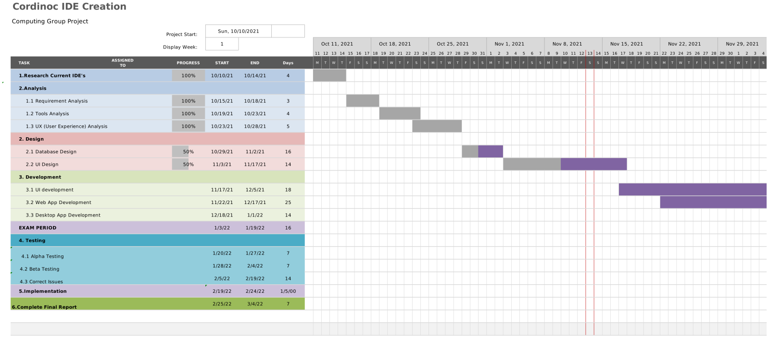

Acknowledgments

* Hegde, R. and Karunakara, K., 2014. Improved Interaction in Web-Based Cloud IDE. Int. J. Innov. Technol. Explor. Eng., 4(4), pp.16-20.
* Arora, P., Dixit, A., BCIIT, D. and Noida, G., 2016. Analysis of cloud IDEs for software development. Int. J. Eng. Res. General Sci, 4(4).
* Hausladen, J., Pohn, B. and Horauer, M., 2014, September. A cloud-based integrated development environment for embedded systems. In 2014 IEEE/ASME 10th International Conference on Mechatronic and Embedded Systems and Applications (MESA) (pp. 1-5). IEEE.
* Aho, T., Ashraf, A., Englund, M., Katajamäki, J., Koskinen, J., Lautamäki, J., Nieminen, A., Porres, I. and Turunen, I., 2011. Designing IDE as a service. Communications of Cloud Software, 1(1).
* Jayasinghe, D.A.I., 2013. Secure IDE with Multi-user Workspace for Cloud Computing (SaaS) (Doctoral dissertation).
* Leisner, M. and Brune, P., 2019, May. Good-bye localhost: a cloud-based web IDE for teaching Java EE web development to non-computer science majors. In 2019 IEEE/ACM 41st International Conference on Software Engineering: Companion Proceedings (ICSE-Companion) (pp. 268-269). IEEE.
* Gadhikar, L.M., Mohan, L., Chaudhari, M., Sawant, P. and Bhusara, Y., 2013. Browser based IDE to code in the cloud. In New Paradigms in Internet Computing (pp. 59-69). Springer, Berlin, Heidelberg.